Test Case: tc003_SPX_Dev5_Crear_Requisicion_Spot_Tipo_Cobro_CC_Urgent
Step 1 - Enter username and password and click to button Enter : Credentials Entered
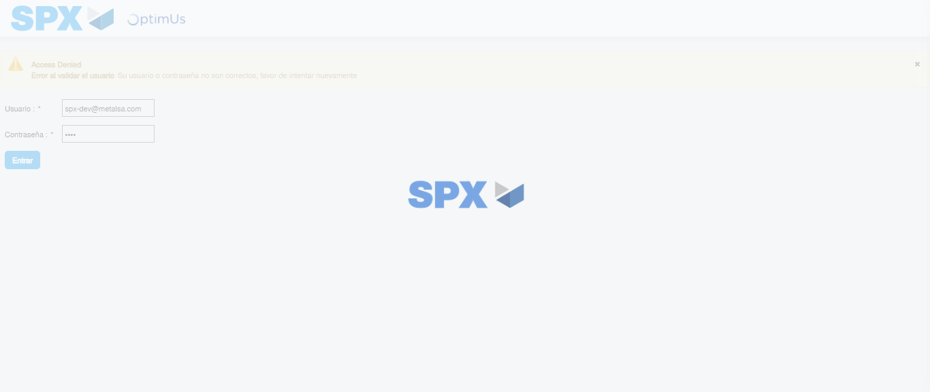Image file-name: QC_Testing-tc003_SPX_Dev5_Crear_Requisicion_Spot_Tipo_Cobro_CC_Urgent-1782242889342

Step 2 - Select to UEN and Access to Spot Buy Requisitions : UEN Correctly selected and Correct access
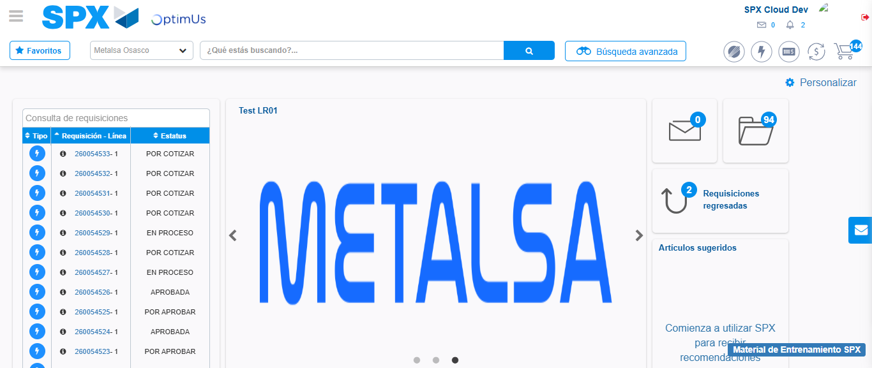Image file-name: QC_Testing-tc003_SPX_Dev5_Crear_Requisicion_Spot_Tipo_Cobro_CC_Urgent-1782242915252

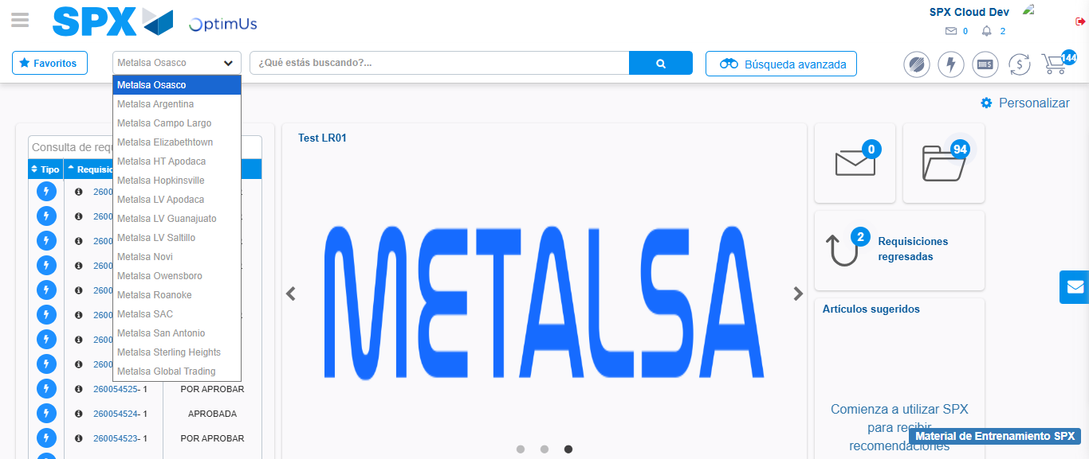Image file-name: QC_Testing-tc003_SPX_Dev5_Crear_Requisicion_Spot_Tipo_Cobro_CC_Urgent-1782242917946

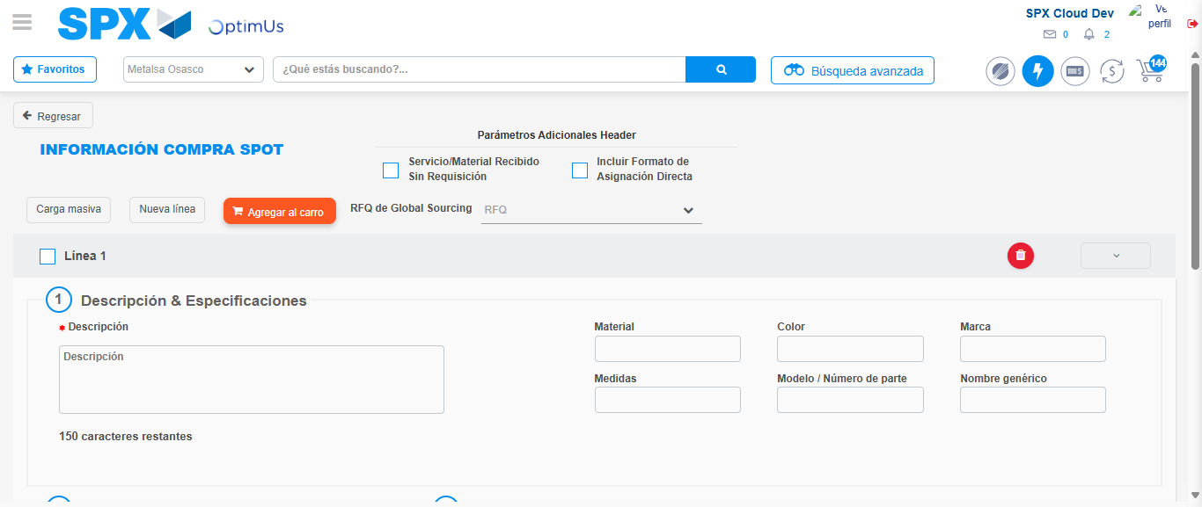Image file-name: QC_Testing-tc003_SPX_Dev5_Crear_Requisicion_Spot_Tipo_Cobro_CC_Urgent-1782242942728

Step 3 - Data Capture Spot Buy Requisition: Data captured correctly
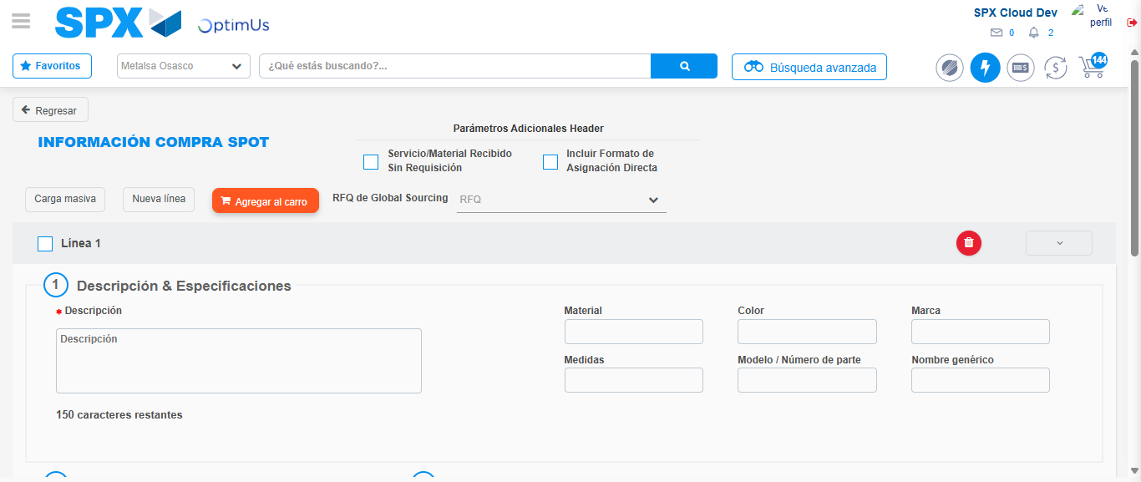Image file-name: QC_Testing-tc003_SPX_Dev5_Crear_Requisicion_Spot_Tipo_Cobro_CC_Urgent-1782242942971

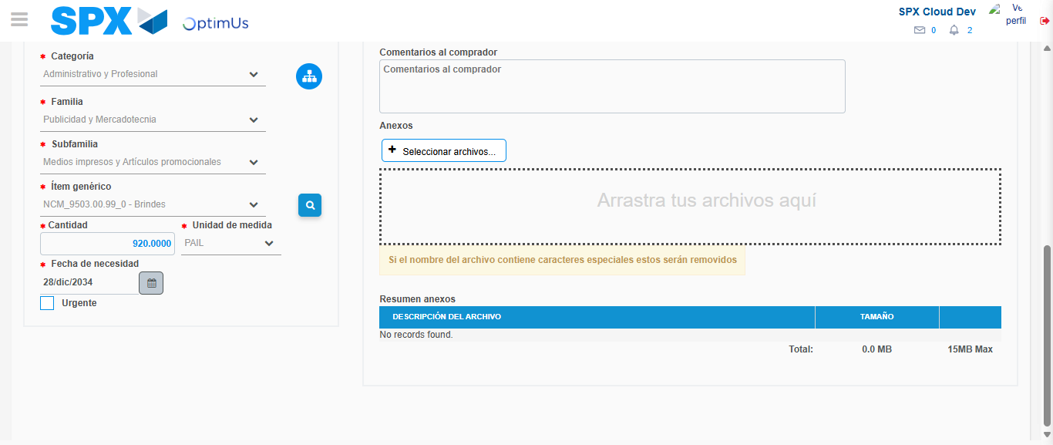Image file-name: QC_Testing-tc003_SPX_Dev5_Crear_Requisicion_Spot_Tipo_Cobro_CC_Urgent-1782242957489

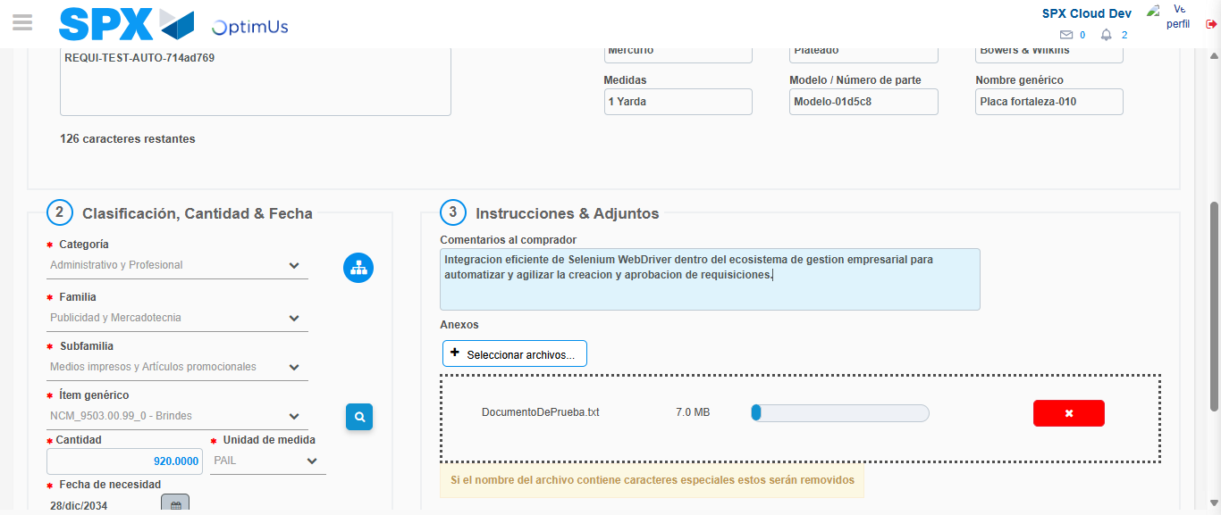Image file-name: QC_Testing-tc003_SPX_Dev5_Crear_Requisicion_Spot_Tipo_Cobro_CC_Urgent-1782242958415

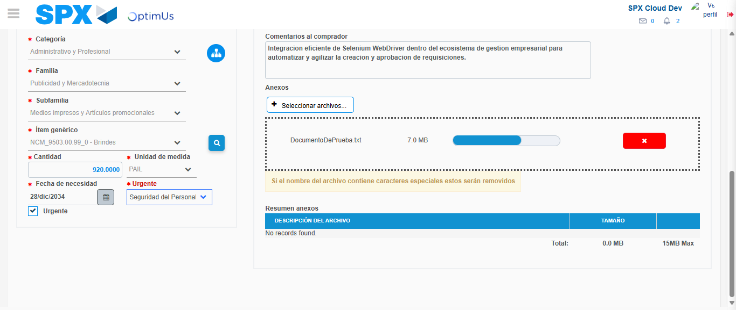Image file-name: QC_Testing-tc003_SPX_Dev5_Crear_Requisicion_Spot_Tipo_Cobro_CC_Urgent-1782242962454

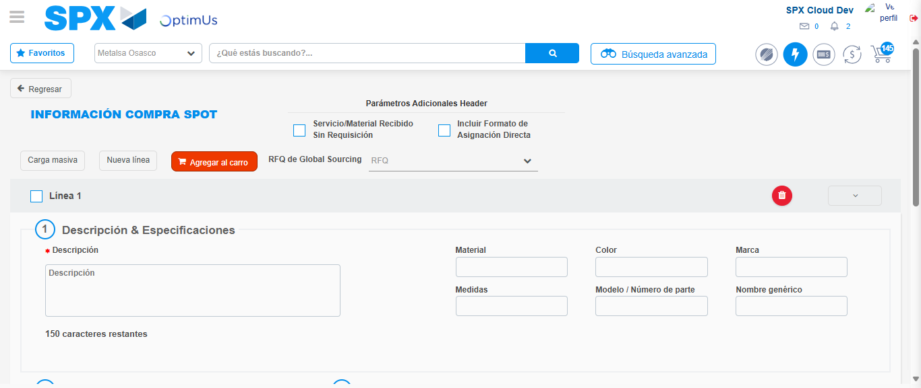Image file-name: QC_Testing-tc003_SPX_Dev5_Crear_Requisicion_Spot_Tipo_Cobro_CC_Urgent-1782242982792

Step 7 - Return to Main Page SPX : Return to Main Page SPX
Image file-name: QC_Testing-tc003_SPX_Dev5_Crear_Requisicion_Spot_Tipo_Cobro_CC_Urgent-1782242915252

Image file-name: QC_Testing-tc003_SPX_Dev5_Crear_Requisicion_Spot_Tipo_Cobro_CC_Urgent-1782242917946

Image file-name: QC_Testing-tc003_SPX_Dev5_Crear_Requisicion_Spot_Tipo_Cobro_CC_Urgent-1782242942728

Image file-name: QC_Testing-tc003_SPX_Dev5_Crear_Requisicion_Spot_Tipo_Cobro_CC_Urgent-1782242985037

Image file-name: QC_Testing-tc003_SPX_Dev5_Crear_Requisicion_Spot_Tipo_Cobro_CC_Urgent-1782242985204

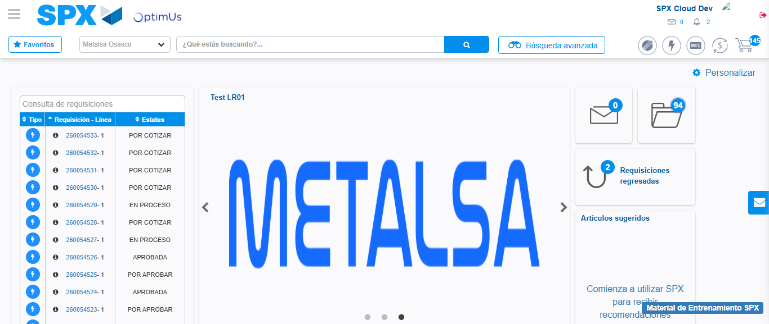Image file-name: QC_Testing-tc003_SPX_Dev5_Crear_Requisicion_Spot_Tipo_Cobro_CC_Urgent-1782243006649

Step 8 - Log Out : Log Out SPX
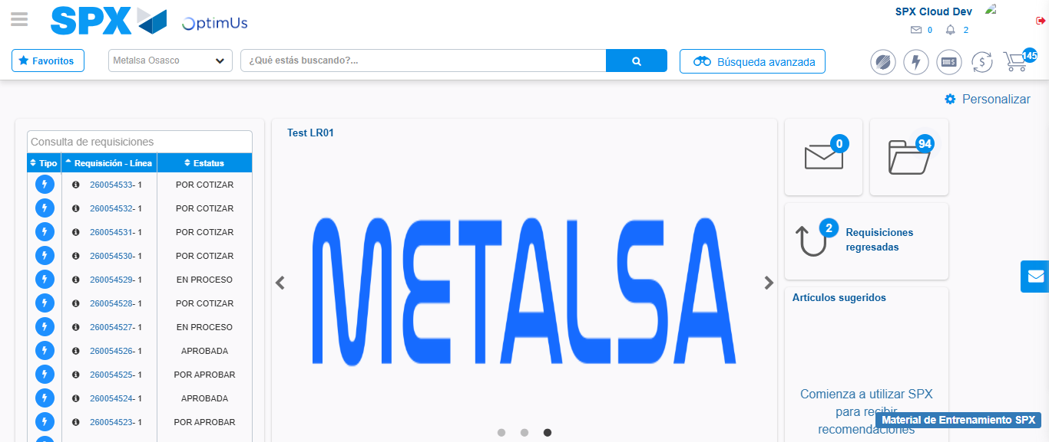Image file-name: QC_Testing-tc003_SPX_Dev5_Crear_Requisicion_Spot_Tipo_Cobro_CC_Urgent-1782243007037

